Industry Standard End to End data Analysis Portfolio Project
Customer Segmentation (Python, SQL, Power BI)
- End to End Industry level Workflow:
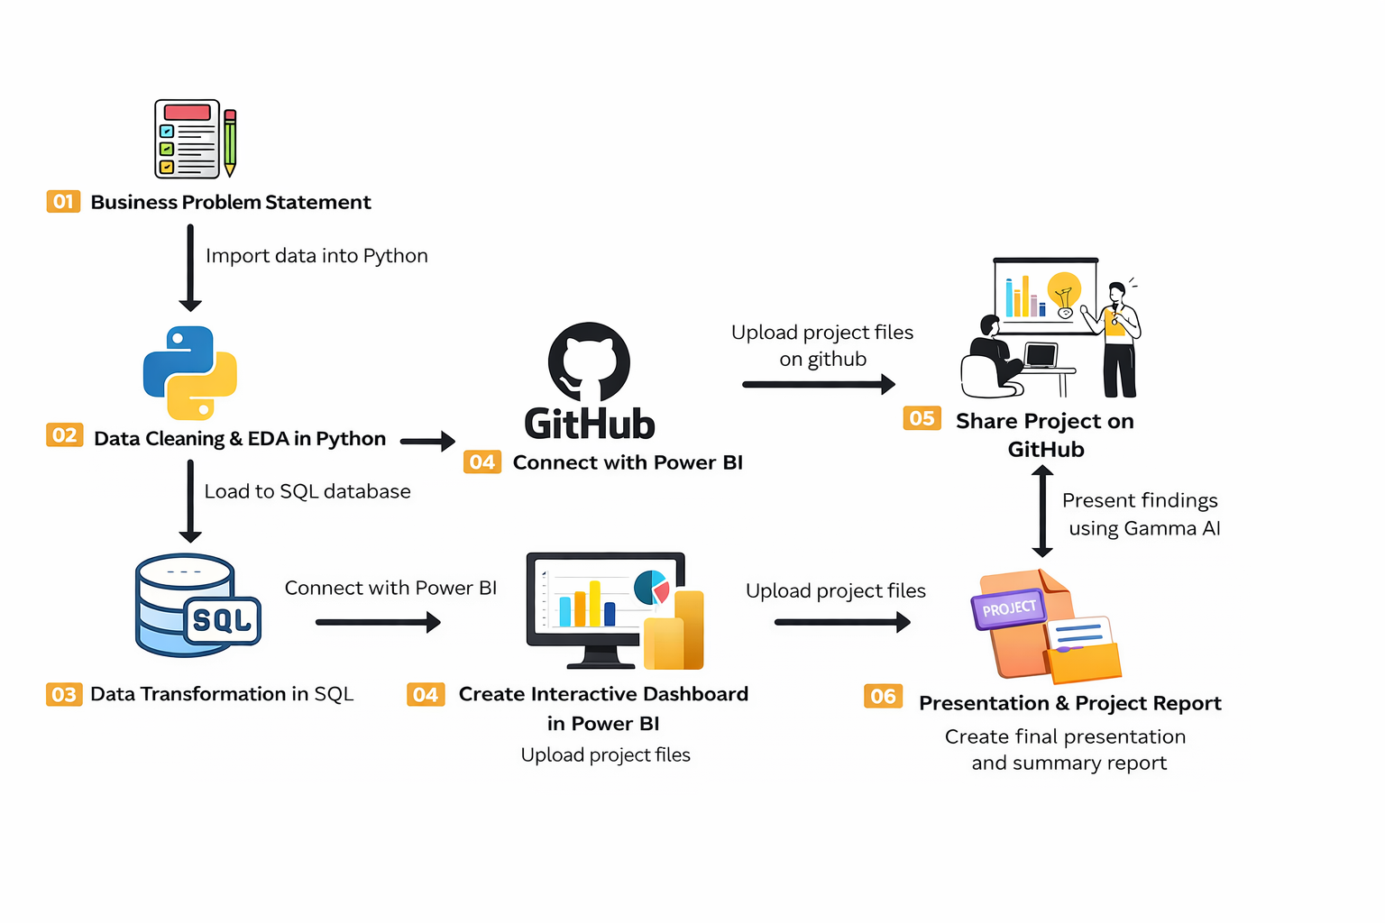
- Problem Statement:
A leading retail company wants to better understand its customers' shopping behavior to
improve sales, customer satisfaction, and long-term loyalty. The management team has noticed
changes in purchasing patterns across demographics, product categories, and sales channels
(online vs. offline). They are particularly interested in uncovering which factors, such as discounts,
reviews, seasons, or payment preferences, drive consumer decisions and repeat purchases.
You are tasked with analyzing the company's consumer behavior dataset to answer the following
overarching business question:

"How can the company leverage consumer shopping data to identify trends, improve
customer engagement, and optimize marketing and product strategies?"

- Problems:
-- Q1. What is the total revenue generated by male vs. female customers?
-- Q2. Which customers used a discount but still spent more than the average purchase
amount?
-- Q3. Which are the top 5 products with the highest average review rating?
-- Q4. Compare the average Purchase Amounts between Standard and Express Shipping.
-- Q5. Do subscribed customers spend more? Compare average spend and total revenue between
subscribers and non-subscribers.
-- Q6. Which 5 products have the highest percentage of purchases with discounts applied?
-- Q7. Segment customers into New, Returning, and Loyal based on their total number of
previous purchases and show the count of each segment.
-- Q8. What are the top 3 most purchased products within each category?
-- Q9. Are customers who are repeat buyers (more than 5 previous purchases) also likely to
subscribe?
-- Q10. What is the revenue contribution of each age group?

